**CONTENTS**

1. **Ceremonial Session………………………………………………………2**

Welcome Address by the president of CAB……………………………....2

Opening Remarks by the Chief Guest of the Forum………………………3

Theme Note address by Mr. Phub Rinzin, Director, CDB………………..4

Launching of Ethical Code of Conduct for Contractors 2019…………….5

Vote of Thanks by General Secretary, CAB………………………….......6

1. **FIDIC……………………………………………………………………..7**

Introduction……………………………………………………………….7

FIDIC Reb Book………………………………………………………….9

FIDIC Yellow Book………………………………………………………9

FIDIC Silver Book………………………………………………………..9

FIDIC Pink Book…………………………………………………………10

FIDIC Green Book……………………………………………………….10

FIDIC Gold Book………………………………………………………...11

FIDIC White Book……………………………………………………….11

FIDIC Blue-Green Book…………………………………………………12

FIDIC Emerald Book……………………………………………………..12

Resolutions of Claims & Dispute………………………………………...12

1. **Alternative Dispute Resolution Dispute Boards…………….14**

Construction Disputes………………………………………….14

Alternative Dispute resolution………………………………….15

Dispute Boards………………………………………………….16

1. **Feedback from the Participants………………………………19**

**CEREMONIAL SESSION**

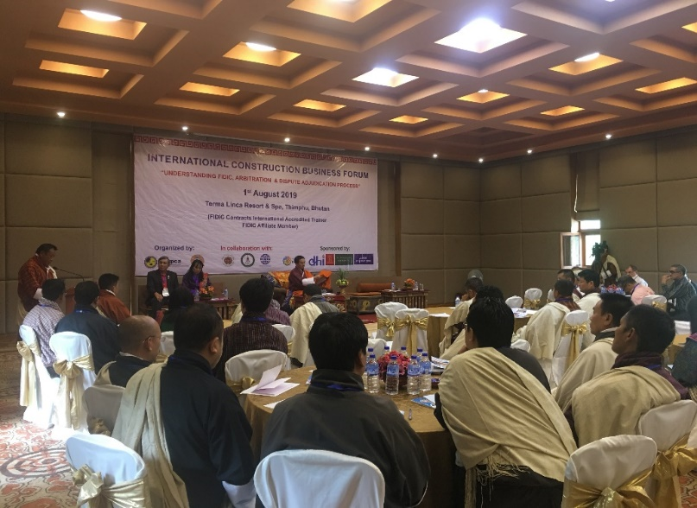**Welcome address by President of Construction Association of Bhutan**

Mr. Thinley Jamtsho, President of Construction Association of Bhutan (CAB) began his welcome note with extending gratitude to Chief Guest of the event, Mr. Dorji Tshering, Hon’ble Minister of Ministry of Works and Human Settlement of Bhutan, Aum Phub Zam, President of Bhutan Chamber of Commerce and Industry, **Mr. Liberito Varias Espiritu,** IFAWPCA Executive Director **and other dignitaries of IFAWPCA and Bhutan. He continued with** introduction of the collaborating partners of the forum, the sponsors from various sectors including institutions and individuals.

Welcome address by President of CAB

**Speaking about Bhutan’s construction industry, its trials and tribulations, he began “As you know, Bhutan has a very short history of modernity. But the pace of development within that timespan has been fast and vigorous. Developmental activities, particularly the building of infrastructures such as roads, bridges and living spaces ushered in an era of buoyant growth and opportunity for Bhutan’s construction industry. Notwithstanding the challenges posed it by nature and policy failures, the construction industry remained unimpeded and ventured forth with our feet firmly on the ground”.**

**President brought to limelight some critical challenges faced by construction industry amongst others those relating to poor tendering and selection process, imprecise terms and conditions of contract, skewed basis for award of contracts, delayed payment, dispute in post execution settlement etc.**

**President began introducing the forum *(Annexure I)* highlighting that FIDIC is the mother of all rules and guidelines relating to bidding and material procurement practices in the construction industry. A large number of countries draw inspiration from the many good practices and standards defined and contained in the FIDIC.**

**He thanked IFAWPCA for sponsoring for one of the resource person of the forum,** Dr. Salvadore P. Castro, FIDIC Contract International Accredited Trainer ***(Annexure II)*** and **making such an expert available in Bhutan where Bhutanese professionals can have direct contact with the him. He shared his gratitude to** Mr. Chirstaain F Grosskopf, International Professional Engineer, **learned specialist in Dispute Avoidance & Adjudication Process** ***(Annexure III)*** who consented to come to Bhutan and impart his knowledge and wisdom pro-bono.

**Opening Remarks by the Chief Guest of the forum, Hon’ble Zhabtog Lyonpo, Mr. Dorji Tshering, Minister of Ministry of Works and Human Settlement**

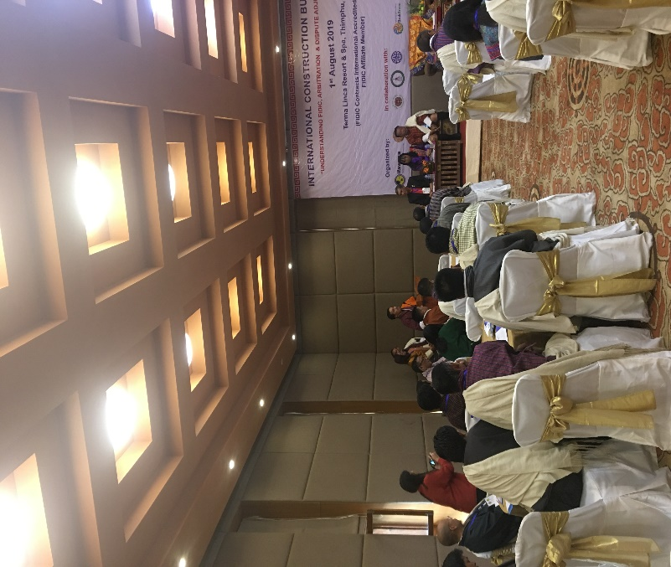Hon’ble Minister of Ministry of Works and Human Settlement of Bhutan graced the occasion as relevant minister for construction industry. He was accompanied by President of Bhutan Chamber of Commerce and Industry and other dignitaries.

Opening Remarks by Chief Guest

The Chief Guest congratulated CAB and other collaborating institutions for incepting such forum for betterment of construction industry of Bhutan. Going back to 15th century, Chief Guest brought to limelight the mega construction of fortresses (Dzongs) by the then ruler of Bhutan who is known as Zhabdrung Ngawang Namgyel. This ruler has built numerous mega structures using locally available resources and techniques.

Hon’ble minister highlighted that the construction industry evolved with rapid urbanization and economic development since 1961 in Bhutan. Thereafter, the industry has seen mechanization, modern techniques, imported resources including labour. With implementations of Five Year Plans, more importance was given to procurement of works and construction industry with allocation of major chunk of annual budget to procurement activities.

Hon’ble minister noted that it is timely to conduct such forums as construction industry has seen numerous challenges lately particularly time and cost overrun which attributes to numerous implications. Further, arbitration cases are on rise which implicates all the parties.

The Chief guest concluded his remarks by thanking the coordinators and resource person in making this forum realize and wished all participants a successful day ahead.

**Theme Note address by Mr. Phub Rinzin, Director of Construction Development Board of Bhutan**

Mr. Phub Rinzin shared brief background on The Fédération Internationale Des Ingénieurs-Conseils (FIDIC) commonly known as International Federation of Consulting Engineers which was founded in Belgium in 1913 and became the foremost representative body for the world’s consulting engineers, with member associations in some 100 countries.

Mr. Phub Rinzin informed the floor that the first publication of contract, known as the Red Book, was a rebadging of the fourth edition of the collaborative endeavour of the Institution of Civil Engineers’ Conditions of Contract. Subsequent editions of the Red Book were published in 1969, 1977, 1987, 1999 and so on, the recent being 2017.

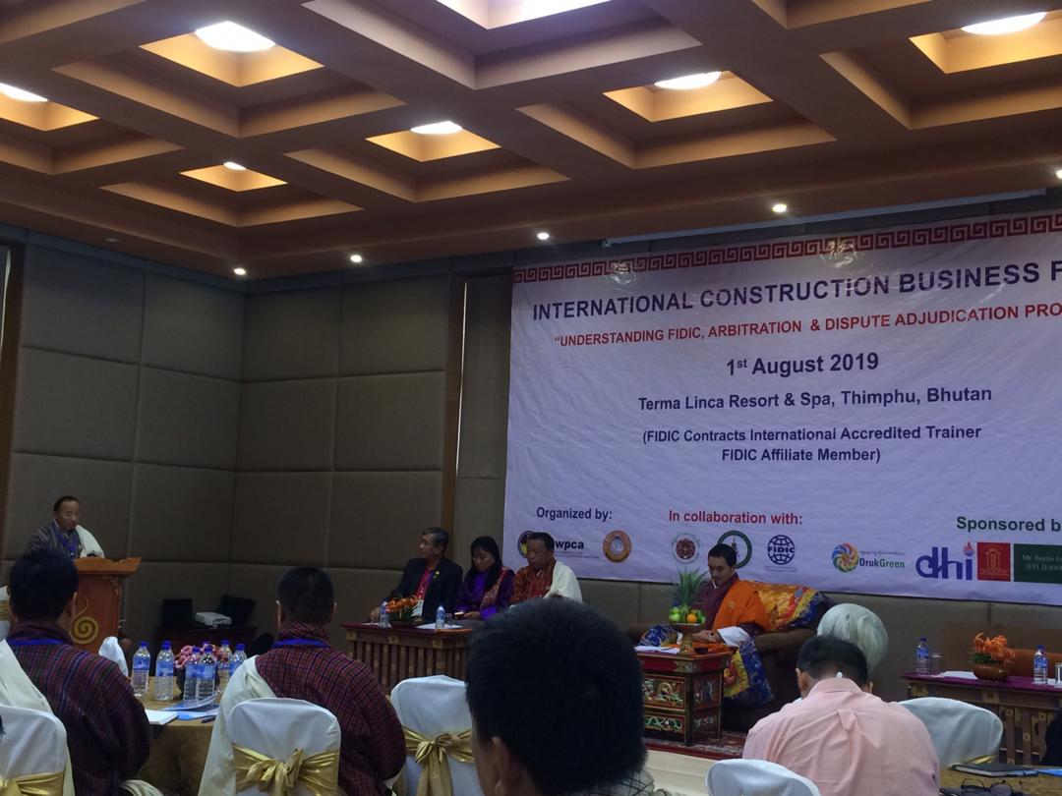Explaining how FIDIC was adopted in Bhutan, he informed that the National Budget and Aid Coordination Division, Ministry of Finance of Bhutan, with funding from the Asian Development Bank, adopted the General Conditions of Contract from FIDIC Conditions of Contract, 1987 as part of the Chapter 17 of the Financial Manual 1998 covering procurement in two subsidiary documents. Further enhancements to the manual was made to repeal provisions in the Financial manual 1988 to address contextual issues and provide for international bidding mechanisms. This early adoption paved the way for the Ministry of Finance to draft and publish the 2009 Procurement Rules and Regulations with contextual amendments and introduction of what we now call the Standard Bidding Documents and three stage process for bidding.

Theme Note Address by Director, CDB

Mr. Phub Rinzin highlighted that the major amendments took hold in the present scenario especially in the procurement of works as major re-categorization of contractors was adopted by the 53rd Construction Development Board meeting and changes to bid capacity calculation following adoption of Mckinsey’s proposal in 2010. He mentioned that Bhutan has gone a long way in procurement and we realize that our system is not perfect and in 2019, Bhutanese construction industry is expecting to adopt new changes in the new Rules and Regulations with anticipation of numerous challenges as well as rewards from the enhancement.

Talking on arbitration of construction disputes, he took back to 2004 when arbitration was first incepted in Bhutan b CDB with constitution of National Arbitration Committee (NAC). Since then, CDB has been acting as arbitration centre and facilitating resolution of construction disputes with the help of the 7 member NAC.

Introducing how arbitration came to Bhutan, he informed the floor that Bhutan became 151st state party to 1958 Convention on the Recognition and Enforcement of Foreign Arbitral Awards (New York Convention) on 26th September 2014 with deposition of the instrument.

He noted that with increase of commercial transactions with other states, investment by members of other states and investment by international and being member of New York Convention and CDB not having legal backing to facilitate arbitration, legal instrument was necessary. Towards this, Alternative Dispute Resolution Act was drafted by Office of Attorney General and enacted by the Parliament on 25th February 2013. Thereafter, CDB handed over arbitration to Bhutan ADR centre on 15th May 2018.

He explained how arbitration is invoked stating that the Standard Bidding Document which derives its authority from PRR clearly mentions in GCC the adjudication and arbitration clause which forms the basis for arbitrators to begin arbitrating a dispute. Any contract having arbitration clause by virtue of having ADR Act gets the privilege to resolve disputes through arbitration.

Highlighting on contractual provisions and status in Bhutan, Mr. Phub Rinzin stated that Procurement Rules and Regulations mentioned few principles of offer and acceptance of contract but comprehensive provisions on rights and obligations and other principles were missing. Further, PRR governed only procurement of works, goods and services but other areas involving contractual transactions were left out which gave birth to the Contract Act 2013 on 20th February 2013 which governs all contractual transactions minimizes disputes on one hand and provides comprehensive basis of resolution of disputes on the other.

Stating the importance of contract, Mr. Phub Rinzin informed the floor that all must be aware of contractual provisions/principles in contract act and FIDIC document (books) while preparing Bidding Documents.

Finally, he ended his address extending heartfelt gratitude to Dr. Salvadore P. Castro, and Mr. Chirstaain F Grosskopf for making all the way to Bhutan as resource person for the forum.

**Launching of Ethical Code of Conduct for Contractors 2019**

***(Annexure IV)***

The floor was informed that CDB published and advocated the Code of Ethics for Contractor in 2014 onwards which could not prove very effective due to lack of regulatory provisions. Thereafter, CDB began formulation of Code of Conduct for contractors which was presented to 69th board meeting on 29th Jan., 2019. Board recommended the CDB Secretariat to consult contractors to inculcate sense of ownership and boost public confidence in the code yet to be published.

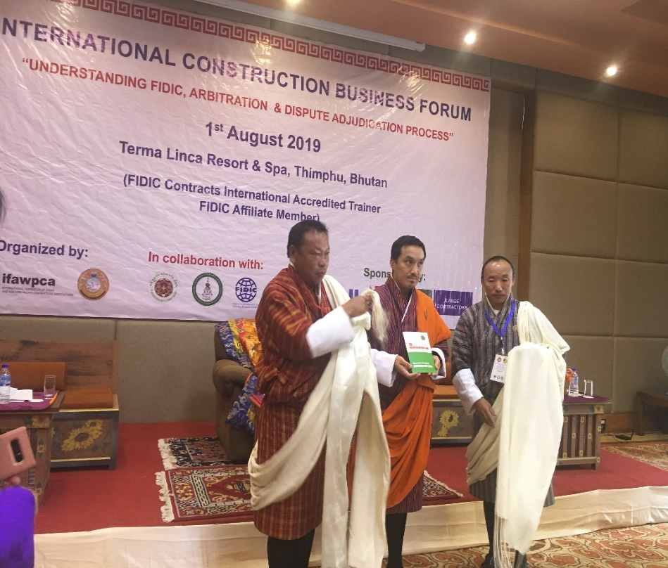

Complying the instruction of the board, CDB secretariat consulted contractors during Refresher course conducted (March, 2019), Induction Course conducted (April, 2019) and Executive members and Dzongkhag Representatives of CAB during AGM of 2019 (May, 2019). After extensive consultation, the board endorsed the code during 70th board meeting held on 28th June 2019.

Launching of Ethical Code of Conduct for Contractors 2019

The forum was communicated that this instrument will guide our contractors and their employees to conduct construction business with professionalism, integrity and accountability ensuring sustainable construction with quality. Further, stringent implementation of this code will achieve 6 principles highlighted in the code which are:

1. Honesty in carrying out responsibilities;
2. Compliance with laws and regulations;
3. Respect for the individual and community;
4. Importance of quality, skills and standards;
5. Importance of safety, health and welfare; and
6. Importance of environmental preservation.

The Ethical Code of Conduct for Contractors 2019 was launched by Hon’ble Minister of MoWHS, Director of CDB and President of CAB which will come into force by 1st August 2019.

**Vote of Thanks by Mr. Wangdi Gyeltshen, General Secretary of CAB**

Mr. Wangdi Gyeltshen, General Secretary of CAB extended warm welcome to all guest, dignitaries, the resource persons and participants for making to the event. In particular, he thanked chief guest for kindly gracing the occasion with is presence.

He further extended gratitude to IFAWPCA, Druk Holding & Investments, Druk Green Power Corporation Ltd., Construction Development Corporation Ltd., Bhutan Power Corporation Ltd., Bhutan ADR Centre and Bhutanese contractor for sponsoring the event.

He thanked Construction Development Board and Bhutan ADR Centre for being collaborating partner for the forum and Civil Society Organization Authority, Ministry of Foreign Affairs, Ministry of Home and Cultural Affairs and Ministry of Works and Human Settlement for their support in making this event materialize.

**MORNING SESSION**

**Introduction to FIDIC (Fédération Internationale Des Ingénieurs-Conseils)**

***(Annexure V)***

**Introduction**

By- Mr. SALVADOR P. CASTRO, JR., FAPM, ACPE, MCIArb, FIDIC Affiliate Member and FIDIC Contracts International Accredited Trainer Country Representative (Philippines), Dispute Resolution Board Foundation (DRBF) Passed, FIDIC-JICA Dispute Board Assessment and Workshop Listed, National List of Accredited Adjudicators, CECOPHIL Chairman & President, SP Castro, Inc. (Philippines and Brunei Darussalam).

Mr. Castro began the session by 10:00 A.M with his introduction and thanking CAB and other organizers for invitation to present on FIDIC and Dispute Resolution to professionals in Bhutan. Further, he conveyed message from FIDIC chair who congratulated Bhutan for conducting such session. With just a half day duration it was known that only introductory part of FIDIC can be presented.

Introducing FIDIC, Mr. Castro mentioned that FIDIC is a global business federation representing national associations of independent consulting engineers. Founded in 1913 by 3 countries (Belgium, France and Switzerland).

Currently, 102 member countries (one-member association per country) and 65 Affiliate Members are present. As of today, FIDIC is located at the World Trade Centre, Geneva, Switzerland. Mr. Castro CAB and other agencies to be member of FIDIC.

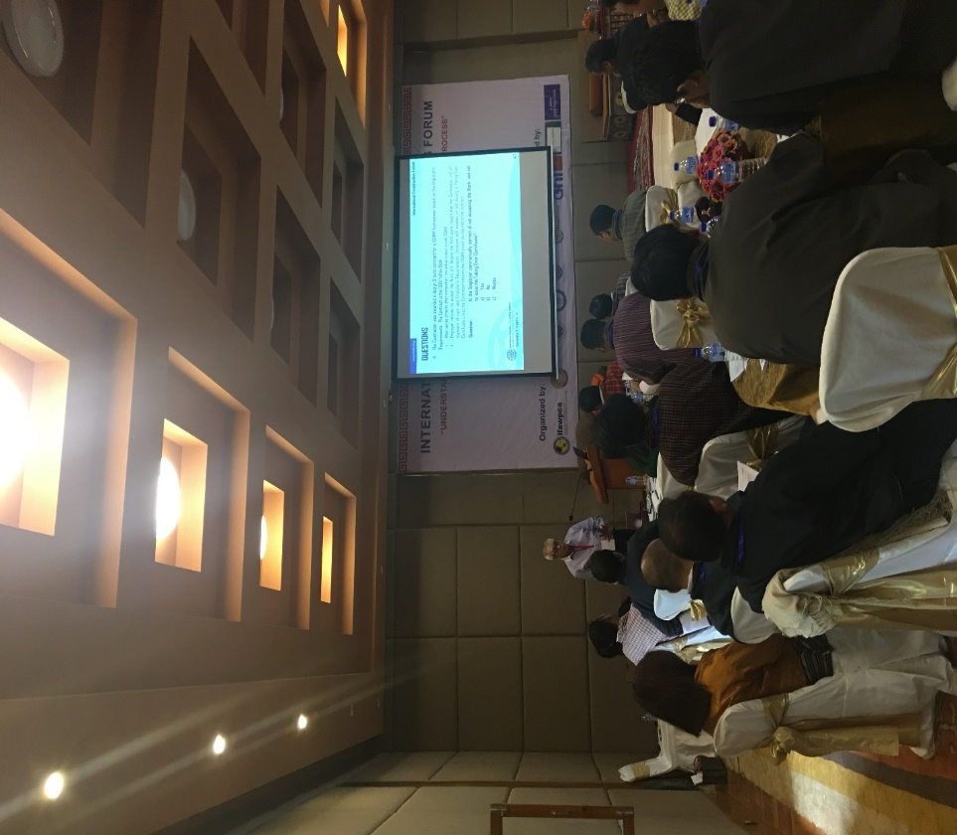 Regional Organizations like Group of Africa member Associations (GAMA), Asia-Pacific (ASPAC), Panamerican Federation of Consultants (FEPAC) and European Federation of Engineering Consultancy Associations (EFCA) were introduced to the forum.

Dr. Salvaldor P. Castro addressing the forum on FIDIC

Talking on FIDIC activities, Mr. Castro mentioned the Annual Conferences, Publications, Trainings, Liason between members and strategic partnership between international agencies amongst others.

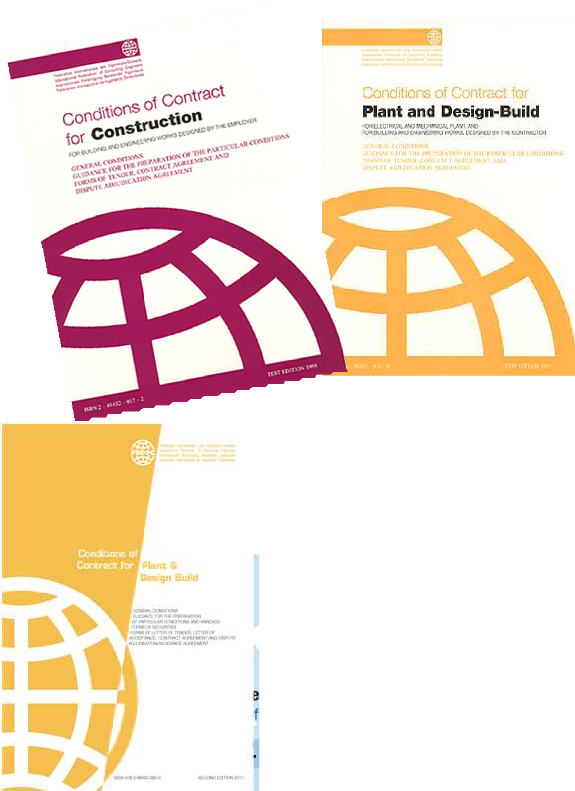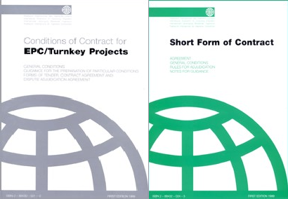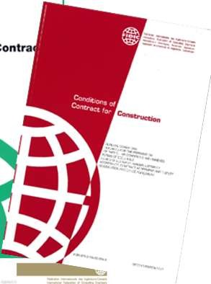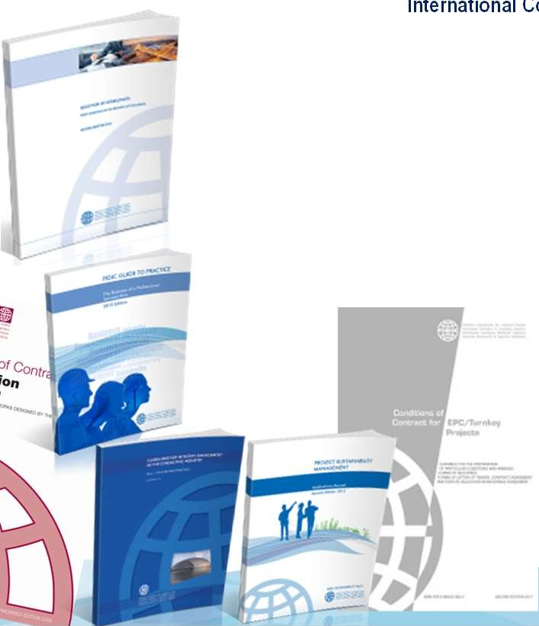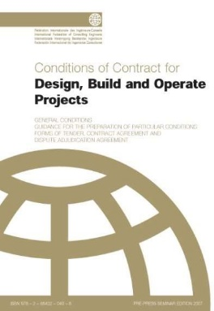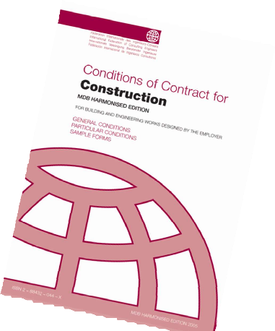

*FIDIC Rainbow Suites*

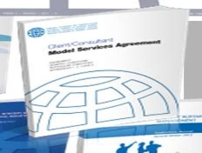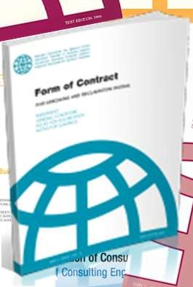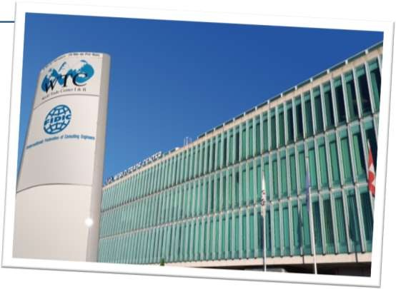

Mr. Castro introduced the FIDIC Rainbow Suites with range of coloured books from red to gold. Different coloured books represents contract books for different types of contract.

**FIDIC Red Book**

Mr. Castro stated that the Conditions of Contract for Construction for Building and Engineering Works designed by the Employer (1st Edition, 1957) known as “FIDIC Construction Contract 1999 or ‘Red Book’. This book is globally the most commonly-used standard form of contract for construction where design is carried out by or on behalf of the Employer although provision is provided for the Contractor to design some elements of the Works. Here, administration of the contract and approval of works is carried out by the Engineer who is employed by the Employer and the payment is based on an actual work done by applying rates per BOQ. This book provides a balanced risk sharing where Employer assumes risks considered as “unforeseeable”. In 1996, the Dispute Adjudication Board was introduced only as an option, but in 1999 it was made part of the Red Book 1999.

Red Book 1999

1st Edition, 1957

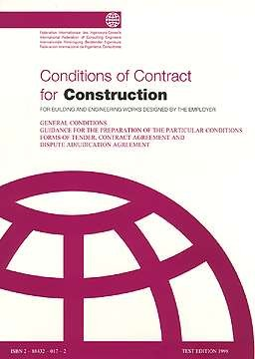

**FIDIC Yellow Book**

Mr. Castro 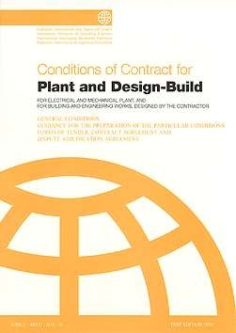stated that Yellow Book provides conditions of contract for construction where Contractor designs and executes the Works in accordance with the Employer’s Requirements with provision for Employer to design some elements of the Works. This Book is applicable for building and engineering works and process plants where a higher degree of offsite manufacture of plant and equipment is foreseen. Mr. Castro emphasized that the supervision of the Works is to be undertaken by the Engineer who is employed by the Employer. Risks are shifted more to the Contractor although the Employer continues to assume risks considered as “unforeseeable”. Interim payments are based on lump sum price according to schedule or milestone. Regarding the dispute adjudication, Yellow Book 1999 provides for ad-hoc Dispute Adjudication (DAB), however, parties are encouraged to engage a Standing DAB to provide a “dispute avoidance” mechanism.

1st Edition, 1963

2nd Edition, 1980

3rd Edition, 1987

**FIDIC Silver Book**

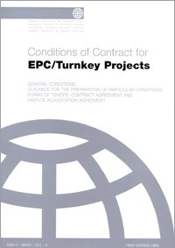Mr. Castro shared the forum that Silver Book is suitable for use on process plants and private infrastructure projects where the Contractor takes on full responsibility for the design and execution of the Works, and where greater level of certainty as to “final price and final time for completion”. Contractor carries out all engineering, procurement and construction including performance tests after completion; a “turn-key” project where the Employer can operate the facility upon completion. No Engineer within the Contract but Employer may appoint an Employer’s Representative with a task of validating the end- performance, operation and maintenance of the completed facility.

Silver Book 1999

1st edition, 1995 as “Orange Book”

Mr. Castro mentioned that the risks for completion as to time, cost and quality are transferred to the Contractor but the Employer has to accept a higher contract price. Contractor is solely liable for the design and assumes full responsibility for the accuracy of the Employer’s Requirements. Due to the higher contract price, usually the Employer and Contractor negotiate and agree on an alternative risk-sharing arrangement in order to reduce the price and such arrangement is defined in the Particular Conditions. Ad-hoc DAB is part of 1999 Silver Book, however, parties are encouraged to engage a Standing DAB to provide a ‘dispute avoidance mechanism’.

Mr. Castro recommends not to use this book if there is no sufficient time or information for tenderers to scrutinize and check the Employer’s Requirements, involves substantial underground work (tunneling) or If the Employer intends to supervise closely or control the Contractor’s work or review most of the construction drawings.

**FIDIC Pink Book**

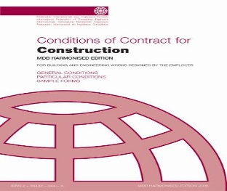Mr. Castro mentioned that this Book is harmonized Red Book Conditions of Contract for Construction for Building and Engineering Works designed by the Employer. This Book was first published in May 2005 and then published revised editions in March 2006 and June 2010. Before 2005, Multilateral Development Banks (MDBs) commonly adopted the FIDIC General Conditions of Contract (including the 1999 Red Book) as part of the standard bidding documents that they required their borrowers or aid beneficiaries to follow.

Pink Book 2010

1st Edition, 2005

Mr. Castro pointed out that the MDBs usually heavily amended the FIDIC General Conditions of Contract by introducing additional clauses. Thereafter, the heads of procurement of the MDBs and FIDIC worked together to produce the Pink Book. This harmonized document includes modified General Conditions of Contract but also contains provisions for Particular Conditions. This Book also includes sample forms for Contract Data (Particular Conditions), Securities, Bonds, Guarantees and Dispute Board agreements.

**FIDIC Green Book**

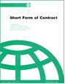Mr. Castro mentioned that Green Book is recommended for fairly simple or repetitive works or works with short duration without the need for specialist sub-contracts. It is suitable for projects comprising of engineering and building works of relatively small capital value.

This Book initially drafted for simple works with a value of less than USD 500,000.00, however, it has evolved and now it is used for non-complex works regardless of value as it is clearly the complexity of the works which will determine if the short form is appropriate or not. Currently no financial limited is stated within the standard form or its accompanying notes.

Green Book 1999

Mr. Castro stated that this book continues to reflect the principles and allocation of risk between the parties as the FIDIC Red and Yellow Books. It allows for either lump sum or other pricing and allows for design by either the Employer or the Contractor. There is no Engineer but Employer may nominate his Representative which may or may not be a professional engaged to manage the Works.

**FIDIC Gold Book**

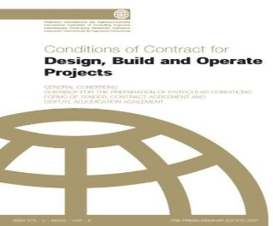Mr. Castro stated that this Book is for projects combining design, construction, and long- term operation and maintenance of a facility awarded to a single contractor or joint venture or consortium. Here, contractor is not responsible for the financing or its ultimate commercial success. The facility’s output (e.g. electricity) will be the Owner’s property and not the contractor’s as for a concession.

Gold Book 2008

Contract duration is divided into ‘Design-Build Period’ and 20-Year Operation Period where the Contractor is required to maintain the facility. Similar to the Turnkey project, Employer, Contractor, Employer’s Representative are the key parties to the Contract.

Mr. Castro mentioned that the special feature in this Book is the Auditing Body responsible to audit and monitor the performance if in compliance with the Operation Management System and Plans. Asset Replacement Fund is maintained for the replacement of items of the plant identified in the Asset Replacement Schedule prepared by the Contractor covering the items and timing of the asset replacement for the continued efficient operation of the Works.

**FIDIC White Book**

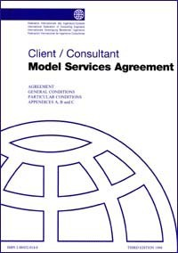

Mr. Castro introduced the White Book recommending to be used for general purposes of pre-investment and feasibility studies, designs and administration of construction and project management, where proposals for such services are invited on an ***international basis***. This Book is an important part of the FIDIC suite and is one of the most widely used forms of professional services contract internationally. FIDIC has also published the second edition of the Sub-Consultancy Agreement to go with the new White Book.

White Book 2006

**FIDIC Blue-Green Book**

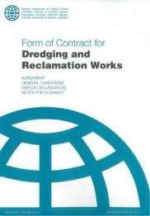Mr. Castro mentioned that Blue-Green Book is prepared in close collaboration with the International Association of Dredging Companies (IADC) which is recommended for dredging and reclamation work. Straightforward document which includes all essential commercial provisions, and which may be used for all types of dredging and reclamation work and ancillary construction with a variety of administrative arrangements. May be suitable for contracts that include, or wholly comprise, contractor-designed works. Employer has a choice of valuation methods.

Blue-Green Book 2006

**FIDIC Emerald Book**

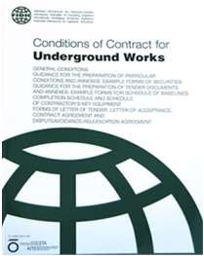Mr. Castro explained to the forum that the Emerald Book is recommended for Underground Works (tunneling and geotechnical uncertainties) which was launched in June 2019 during the FIDIC Asia-Pacific Contract Users’ Conference, Hong Kong published in joint endeavor with the International Tunneling and Underground Space Association (ITA-AITES). The Book addresses the risk related to subsurface physical conditions which are not possible to assess with sufficient precision in advance of the Contract, and therefore cannot be assigned entirely to the Contractor.

Emerald Book 2019

**Resolution of Claims & Disputes**

**Dispute Avoidance by an Engineer**

Mr. Castro explained that in case of issues or claims filed with the Engineer (appointed by the Employer), consult each of the party to try and reach an agreement. If no agreement is reached, the Engineer shall render a fair determination taking due regards of all circumstances. If an Engineer’s determination is not agreed by either of the parties, then the dispute can be referred to the DAB/DB for decision.

**Dispute Adjudication Board (DAB)/Dispute Board (DB)**

Mr. Castro explained that DAB/DB shall render a “real time” decision (within the stipulated time) which shall be enforced promptly. The decision shall become final and binding unless amended by an amicable settlement or arbitration.If the DAB/DB decision is not accepted by any of the parties then the dispute may be referred to arbitration.

However, before arbitration will commence, parties may try to reach an amicable settlement either by negotiation, mediation or conciliation. Unless settled amicably, any dispute in which the DAB’s decision has not become final and binding shall be finally settled by international arbitration. (Parties may opt to proceed to arbitration without pursuing an amicable settlement.)

**Arbitration**

Mr. Castro explained that 1999 FIDIC Contracts provides dispute shall be finally settled under the ICC Rules of Arbitration with 3 arbitrators appointed in accordance with ICC Rules. But MDB Harmonized Edition 2010 provides that international arbitration only commences in case of foreign contractor but domestic arbitration in accordance with

the country’s arbitration rules in case of Domestic Contractor.

**Roles of the Dispute Board**

**Dispute Avoidance**

Mr. Castro explained that DB conducts periodic site visits and meetings, in order for DB to become and remain acquainted with the progress of the Works and any actual or potential problems or claims and endeavor from becoming disputes. At the request of both parties, the DB provides “informal opinion” or “assistance” to timely resolve potential conflicts that may lead to disputes. DB may, also, encourage the parties to resolve their disagreements on their own. However, if the disagreement is too entrenched, the DB can intervene with informal assistance to help the parties resolve the matter by agreement.

**Dispute Resolution**

Regarding dispute resolution, DB timely render “real time” decision on a dispute at the request on one or both parties. DB decision shall be promptly complied and is binding unless amicably settled or by an arbitral award.

**Key Qualifications of the Dispute Board**

Mr. Castro informed that DB must have following qualifications:

1. Knowledge of the project type and experience in the industry;
2. Knowledge of the contract;
3. Language and understanding of the culture;
4. Trainings in dispute board, dispute resolution; and
5. Impartiality/fairness, availability/capability to travel.

**Lists of Dispute Board**

Mr. Castro mentions following few DBs amongst others:

1. FIDIC President’s List of Approved Adjudicators;
2. National List of Approved Adjudicator by FIDIC’s Member Associations;
3. DRBF website, member resumes;
4. ICC but has no official list; and
5. Others through recommendations.

**AFTERNOON SESSION**

**Alternative Dispute Resolution Dispute Boards**

***(Annexure VI)***

By **–** Mr. Christaain F Grosskopf, International Professional Engineer, Certified International Project Manager, Member of Dispute Resolution Board Foundation, Associate of Association of Arbitrators, **Learned Specialist in Dispute Avoidance & Adjudication Process.**

**Construction Disputes**

**Introducing the international scenario of construction dispute, Mr. Christaain said that the** human factors and misunderstanding of contractual obligations continue to be a primary cause of disputes and the **r**egions that are utilizing early dispute avoidance techniques have been most successful.

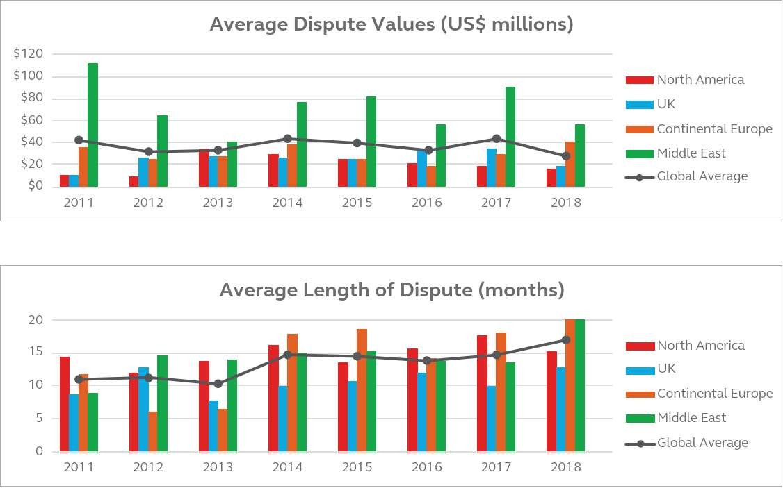

**Graph A**

.

**Graph B**

The Graph A shows average dispute values in millions versus year (2011 to 2018) in North America, United Kingdom, Continental Europe and Middle East and the line graph shows global average of disputes in millions.

The Graph B shows average length of dispute in months in millions versus year (2011 to 2018) in North America, United Kingdom, Continental Europe and Middle East and the line graph shows global average of length of disputes in months.

**Alternative Dispute Resolution**

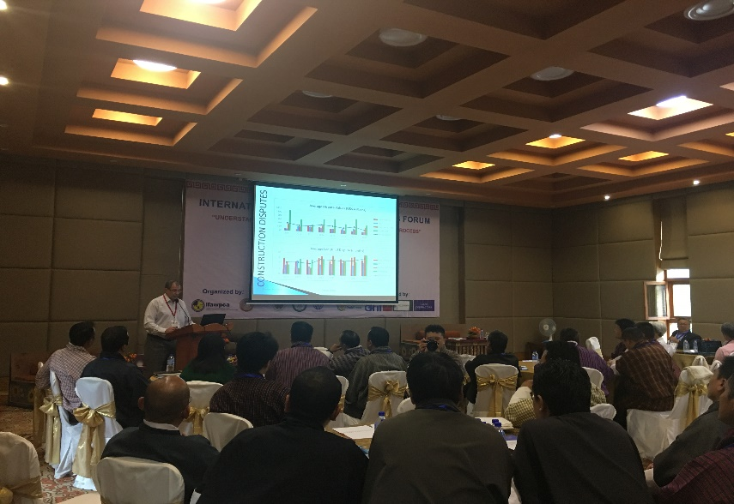Mr. Christaain introduced Alternative Dispute Resolution (ADR) to the forum as settlement of disputes outside National Courts which is composed technique to ‘Assist to Reach Consensus’ and ‘Imposed Decision’.

The technique to Assist to Reach Consensus includes Negotiations, Mediation, Expert Opinion and others and technique to Imposed Decision includes Arbitration, Adjudication, Expert Determination and others.

**Historical Developments**

Mr. Christaain briefly presented the historical development as follows:

|  |  |  |  |  |
| --- | --- | --- | --- | --- |
| Early  1970s: | | Tunneling industry conducted studies on new  approaches to dispute resolution | |  |
| 1975: | | First DB used on second bore of I-70 Eisenhower  Tunnel (1975) | |  |
| 1981: | | First international DB, El Cajon Dam, Honduras | |  |
| 1992: | | FIDIC issues DB Supplement, 4th ed. Red Book | |  |
| 1995: | | The World Bank makes DBs mandatory for all  World Bank-financed projects >US $50M | |  |
| 1997: | | Asian Development Bank & European Bank for Reconstruction & Development adopt DB  Approach | |  |
| 1999: | | FIDIC rainbow suite introduces Standing and Ad  Hoc Dispute Adjudication Boards | |  |
| 2004: | ICC introduces DB rules | |
| 2006: | 9 Multilateral Development Banks adopt DBs, and  ICC and ICE publish DB Rules | |
| 2017: | Indonesia introduces Dispute Boards into Law no 2,  2017 re: Construction Services | |
| 2017: | FIDIC – All "rainbow" contracts includes a DAAB | |
| 2018: | World Bank signed 5 year exclusive use of FIDIC  Contracts | |
| 2019: | Caribbean Development Bank signed 5 year  exclusive use of FIDIC contracts | |
| 2019: | FIDIC & China International Contractors' Association signed MoU for working towards using FIDIC | |

**Dispute Boards**

Mr. Christiaan explained that international instruments define Dispute Board as a board set to be impartial from the Employer, the Contractor or Engineer, and the members repeatedly visit the sites to give advices or decisions in order to settle contractual disputes preventing them from escalating into arbitration or litigation. DB is independent in its functions, have adequate knowledge about the matter in issue and the board is available to the parties whenever issues arise.

**Functions of Dispute Board**

Mr. Christaain explained the two major functions of Dispute Board as follows:

1. **Dispute Avoidance**
2. Conducts periodic site visits and meetings, in order for DB to become and remain acquainted with the progress of the Works and any actual or potential problems or claims and endeavor from becoming disputes;
3. At the request of both parties, the DB provides ‘informal opinion’ or ‘assistance’ to timely resolve potential conflicts that may lead to disputes;
4. Encourage the parties to resolve their disagreements on their own; o
5. Intervene with informal assistance to help the parties resolve the matter by agreement.
6. **Dispute Resolution (Adjudication)**
7. DB timely render “real time” decision on a dispute at the request on one or both parties; or
8. DB decision shall be promptly complied and is binding unless amicably settled or by an arbitral award.





**ADHOC BOARD**

**STANDING BOARD**

**DISPUTE BOARD**



**ADJUDICATION**

**ADJUDICATION**

**AVOIDANCE & ADJUDICATION**

***\*\*\* functions of Dispute Board in brief***

**The process of Dispute Board**

Mr. Christaain demonstrated the process as to how DB & FIDIC function in brief as follows:

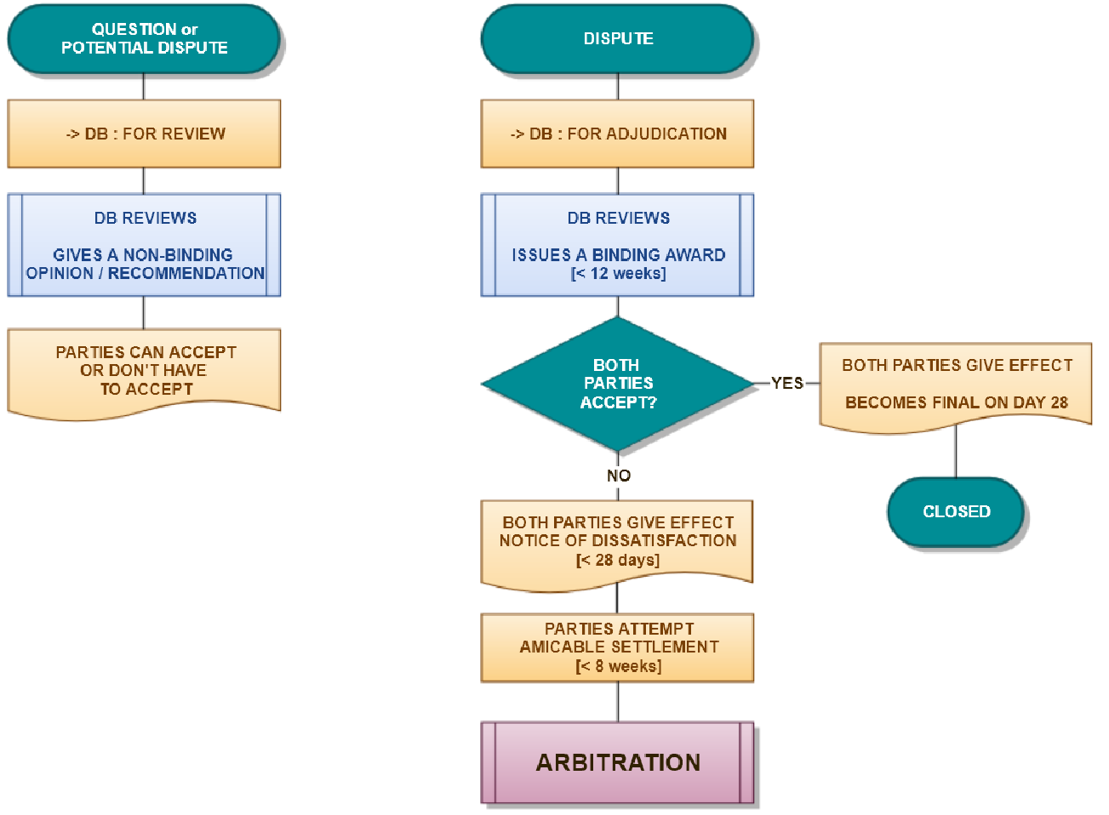

Bhutan: Aug 2019 Dispute Boards

**Appointment of the Dispute Board**

Mr. Christiaan mentioned that the Dispute Board is a creation of contract where parties establish and empower a dispute board with certain jurisdiction to advice or hear on the resolution of their differences or render decision on the dispute presented. DB members are impartial and subject to the approval by both parties and sign Three-Party Agreements. Standing DB members are appointed at the start of the project and end upon completion. DB members DB’s fees and expenses shall be shared equally by the Parties.

**DB and other ADR mechanisms**

Mr. Christaain demonstrated the DB & ADR mechanisms as follows:

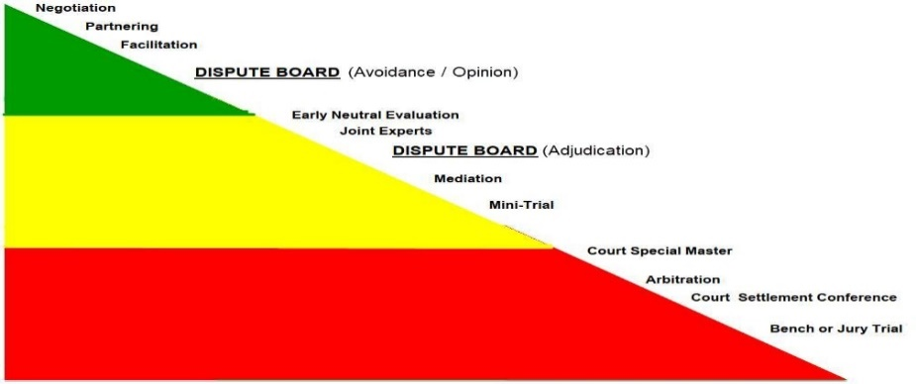

Dispute Boards

Bhutan: Aug 2019

C O N T R O L

COST / TIME

**Effectiveness of DB**

Mr. Christiaan showed that BD as per research by Dispute Resolution Board Foundation showed DB proved effective is avoidance and early resolution of disputes as follows:

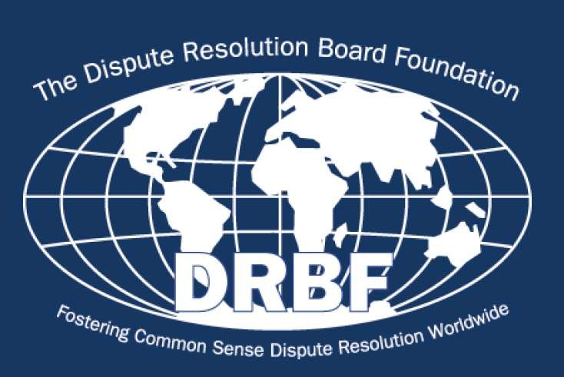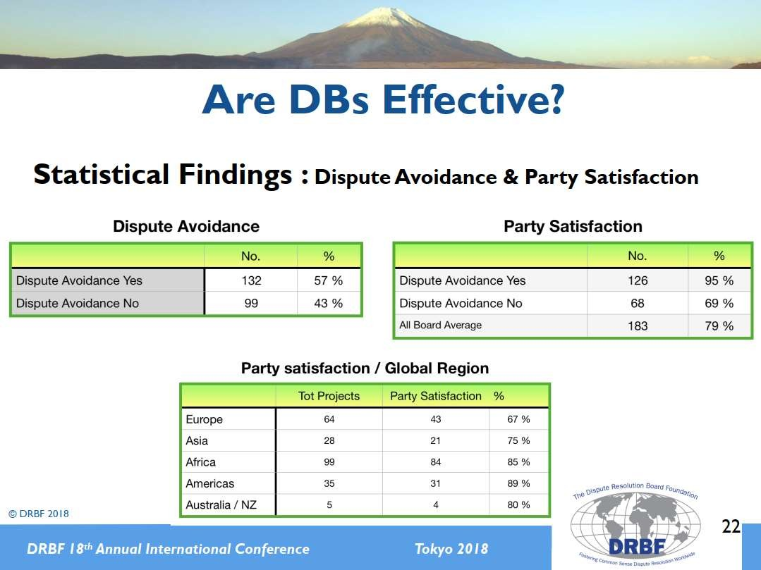

Mr. Christiaan highlighted that from the reported 512 Decisions of DB, only 32 were referred to arbitration, and only 7 (<1.4%) of these were overturned in the process. The bulk of the DB Decisions were accepted by the Parties as such, or were subsequently used to sort out the differences amicably. The DB Process had a success rate of 94% in avoiding expensive follow-on dispute resolution procedures.

**FEEDBACK FROM THE PARTICIPANTS**

This event witnessed participation of total 73 professional comprising of executives, engineers, lawyers, Managers, supervisors from government, corporations and private sector with few international participants from IFAWPCA members ***(Annexure VII).*** Of total 73 members, 29 of them has given the feedback on International Construction Business Forum.

**Some pertinent feedbacks & suggestions are reproduced as follows:**

***(Annexure VIII)***

**Feedbacks**

**“**The Conference on International Construction Business Forum seems very useful to all the Engineers around the country. The topic covered throughout the session enhanced my knowledge and I anticipate it will help me to deal with any kind of disputes related to construction in smarter way”.

“The Course presented is very informative and decisive. It provide the opportunities to learn more on dispute resolution process”

“Informative, brief and technical aspects of construction are well interpreted”.

“Bhutan exposes the closed up Bhutanese to international norms /practices enabling comparison of our system/practice to those prevailing in outside world. Regarding the disputes and mediation it is case of later development due to changes in interpretations rise of expectations or attempt of implicating others for own faults in some cases while in others it is cases of holding the client party responsible for their orders”.

“It was an informative session and the interactions were more important for future noting. Express my gratitude to the organizers for organizing the session”.

“This type of seminar/forum is very informative and educative. Country like ours need to learn much more in terms of arbitration and dispute adjudication. Both Government employees and Pvt. sectors will benefit from such events. Look forward for similar forum in future”.

“Forum is very useful, educative and would be more efficient and effective if implemented in similar ways to minimize disputes”.

“The business forum was well organized. I would suggest that there was less participants from Government agencies. I feel that CDB should take bigger role with Government procuring agencies and MoF, so that some sort of dispute avoidance mechanism could be initiated as we lose lots of time in contract dispute now”.

“ICBF should be organized frequently so that all people in Construction Business are educated about the system”.

“I found workshop very informative and a great basis for comparison to what we do in Bhutan. However, many of the statutory laws prevent some of the good initiatives or recommendations that are part of international best practices”.

“Very well experienced resource speakers of the forum. Very good and comprehensive contents. Well coordinated events”.

“The programs was interesting and very educative as well as informative. I wish to attend more of such program which would enhance our knowledge on dispute resolution in international level”.

“I find this type of forum such very useful for our day to day activities especially for those who deals with the construction activities. It is also good to gained some knowledge on the FIDIC procedure”.

“Topic on undertaking arbitration disputes adjudication are very interesting & informative topics. Clearly relevant for the construction industry to mitigate cost and time over runs. Speakers are well verse in their specific topics”.

“The forum is informative, educative & very timely given the inception of ADR centre in Bhutan logically by virtue of our PRR & SBD being derived in relevance to FIDIC. The forum co-relates our procurement of works process in alignment with FIDIC system”.

“Very impressed by the quality of speaker. The preparation of the host, attendees and interest of the Bhutan contactors and government regulation”.

“The seminar was very informative, interactive and structured. It helped me get familiar with FIDIC, its activities, contracts and attributes. The exercise are very interactive and was helpful as it was scenarios contractors/employers/engineers go through a daily basis. Dispute Board seminars was very informative & clear. It talked about what DB is, their functions & what the resolutions are. Over all now I am aware of what FIDIC and DB and their role after attending the ICBFB seminars”.

**Suggestions for further improvement**

“The forum could have been for least three days to learn more on FIDIC roles and conduct once a year”.

“Suggest to have similar forum in frequent to make better understanding on the FIDIC of dispute avoidance knowledge to curb any dispute in the procurement process both initial and post bids”.

“Increase the duration and provide classes with more arbitration dispute resolved process”.

“CAB, CDB & BADRC should organize more seminars/workshop on international arbitration so that more investors are encouraged for outside and awareness for arbitrators”.

“I would like to suggest that the relevant Bhutanese agency actually present to the contractors and the forum the constraints that Bhutanese face in terms of contracts, contacts administration and dispute resolution”.

“Look forward to similar forum with more focus on our procurement & dispute resolution process. To align the forum in our Bhutanese process which should lead to refining our procurement system & document that is PRR & SBD”.